**CSVSerDe**

Creating table to store csv file:

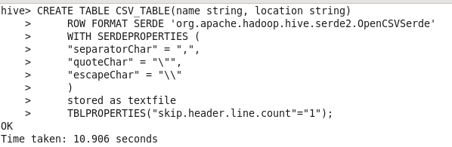

Data:



Loading csv data into table:



Select * from csv_table;

